Chapter 17, Solution 31.

If 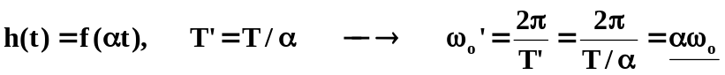

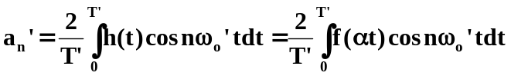

Let

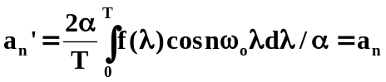

Similarly, 